SNS-EEC LAB COMPRE

**Name:** Vishwas Vasuki Gautam **ID no:** 2019A3PS0443H

1. **a) Code:**

t = -4:0.001:4;

% 1a) the signal x(t)

x = (t<0).*0 + (t>=0 & t<1).*1 + (t>=1 & t<2).*(-t+3) + (t>=2 & t<3).*1 + (t>=3 & t<4).*(t-2) + (t>=4).*0;

plot(t, x, 'b');

title("Plot of x(t)");

xlabel("Time"), ylabel("x(t)");

**Output:**

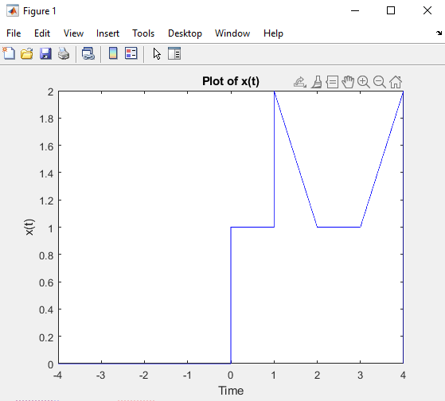

**I, II, III, IV Answers:**

**Code:**

t = -4:0.001:4;

% 1a) the signal x(t)

x = (t<0).*0 + (t>=0 & t<1).*1 + (t>=1 & t<2).*(-t+3) + (t>=2 & t<3).*1 + (t>=3 & t<4).*(t-2) + (t>=4).*0;

clf

subplot(411)

plot(t, x, 'b');

title("Plot of x(t)");

xlabel("Time"), ylabel("x(t)");

% I. x(t-1)

t1 = t-1;

x1 = (t1<0).*0 + (t1>=0 & t1<1).*1 + (t1>=1 & t1<2).*(-t1+3) + (t1>=2 & t1<3).*1 + (t1>=3 & t1<4).*(t1-2) + (t1>=4).*0;

% II. x(2t+1)

t2 = 2*t+1;

x2 = (t2<0).*0 + (t2>=0 & t2<1).*1 + (t2>=1 & t2<2).*(-t2+3) + (t2>=2 & t2<3).*1 + (t2>=3 & t2<4).*(t2-2) + (t2>=4).*0;

% III. x(-t+4)

t3 = -t+4;

x3 = (t3<0).*0 + (t3>=0 & t3<1).*1 + (t3>=1 & t3<2).*(-t3+3) + (t3>=2 & t3<3).*1 + (t3>=3 & t3<4).*(t3-2) + (t3>=4).*0;

subplot(412)

plot(t, x1);

text(0, 2.15, "Plot of x(t-1)");

xlabel("Time"), ylabel("x(t-1)");

subplot(413)

plot(t, x2);

text(0, 2.15, "Plot of x(2t+1)");

xlabel("Time"), ylabel("x(2t+1)");

subplot(414)

plot(t, x3);

text(0, 2.15, "Plot of x(-t+4)");

xlabel("Time"), ylabel("x(-t+4)");

**Output:**

